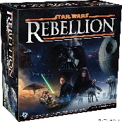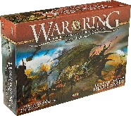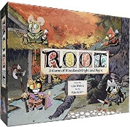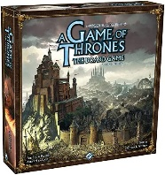

**Star Wars: Rebellion**

*Fantasy Flight Games*

**War of the Ring**

*Ares Games*

**Root**

*Leder Games*

*Fantasy Flight Games*

**A Game of Thrones: The Board Game**

***Favourite Games***

* Managing too many complicated game mechanics manually
* Trying to play multiplayer games over the internet rather than in person
* Making space for more board games

**Josh Mitchell**

***Frustrations***

Board Games

Video Games

Online Games

Single player

Multiplayer

***Preferences***

* Connecting with people who enjoy getting together to play board games
* Visiting board game cafés
* Purchasing newly released board games
* Following board game developers on social media and reading board game magazines

***Habits***

* Attend a board game convention and win a competition
* Collect over 100 board games
* Discover and support new companies making innovative board games
* Meet new people who share his interest in board games and establish regular play sessions
* Form a board games club

***Goals***

Josh is a graduate of a Master’s degree in IT, having recently secured a position at a company as an IT Specialist. He is passionate about gaming and spends much of his free time playing board games with his friends. He has a natural talent for strategic thinking and planning.

***About***

***Male, 27***

***London, UK***

***In a relationship, no children***

***IT Specialist***

***Master’s Degree - IT***

***Age/Sex***

***Location***

***Relationship Status***

***Job Title***

***Education***

USER PERSONA